

Department of Information and Communication Technology
Faculty of Technology
University of Ruhuna

Database Management Systems Practicum
ICT 1222
Assignment 02 – Final Report
Group Number 09

Submitted by : TG/2023/1715 A.P.G.H.Pramoda
TG/2023/1771 R.W.V.Madusanka
TG/2023/1763 G.G.N.S.Bandara

Contents

1. Brief Introduction to the Problem/Group Project 3
2. Brief Introduction to the Solution 3
3. Proposed ER/EER diagram 4
4. Proposed Relational mapping Diagram 5
5. Table structure of your solution 6
6. Architecture of your solution 13
7. Tools and technologies that you have used 13
8. Security measures that have taken to protect your DB 14
Accounts/Users 14
10. Code snippets to support your work 14
11. Problems Faced During Development 25
12. Solutions to Overcome Identified Problems 25
13. If I were to host the database backend, We would choose a cloud provider like 25
14. If you are going to host your backend in a cloud environment what are the things/changes that you have to do in your backend 25
15. Individual contribution to the backend development 26
16. References 40

9. Brief description about DB Accounts/Users and the reasons for creating such

Brief Introduction to the Problem/Group Project
The integration of a Learning Management System (LMS) in the Faculty of Technology has modernized how academic data is handled and solved many issues that came with traditional manual methods.
Streamlined Data Management: The system automates the recording of student details, marks, and attendance. This reduces human errors and improves efficiency.
Centralized Information Access: All academic records, including course details, assessments, and attendance, are stored in one unified database. This ensures consistency and makes it easy to retrieve information.
Enhanced Accuracy and Transparency: Automated calculations for attendance percentages, eligibility for continuous assessment, and final results ensure fairness and reliability.
Efficient User Role Management: Different user accounts such as Admin, Dean, Lecturers, Technical Officers, and Students provide secure, role-based access to information.
Improved Data Security: With MySQL privileges and controlled access levels, the system ensures the confidentiality and integrity of academic data.

Brief Introduction to the Solution
To tackle these challenges, our team created a secure and automated Learning Management System. The system simplifies data entry, updates, and retrieval, cutting down on errors and delays. Primary keys and validations stop redundancy and keep data accurate. Quick keyword searches allow fast access to information, and reliable backup options protect against data loss. Access is limited to authorized users, improving security and confidentiality. Overall, the system boosts efficiency, accuracy, and data integrity while lowering manual work and maintenance costs.

Proposed ER/EER diagram

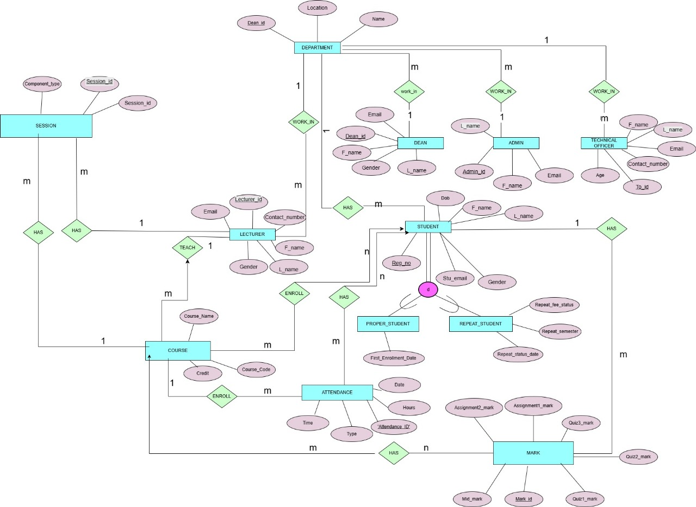

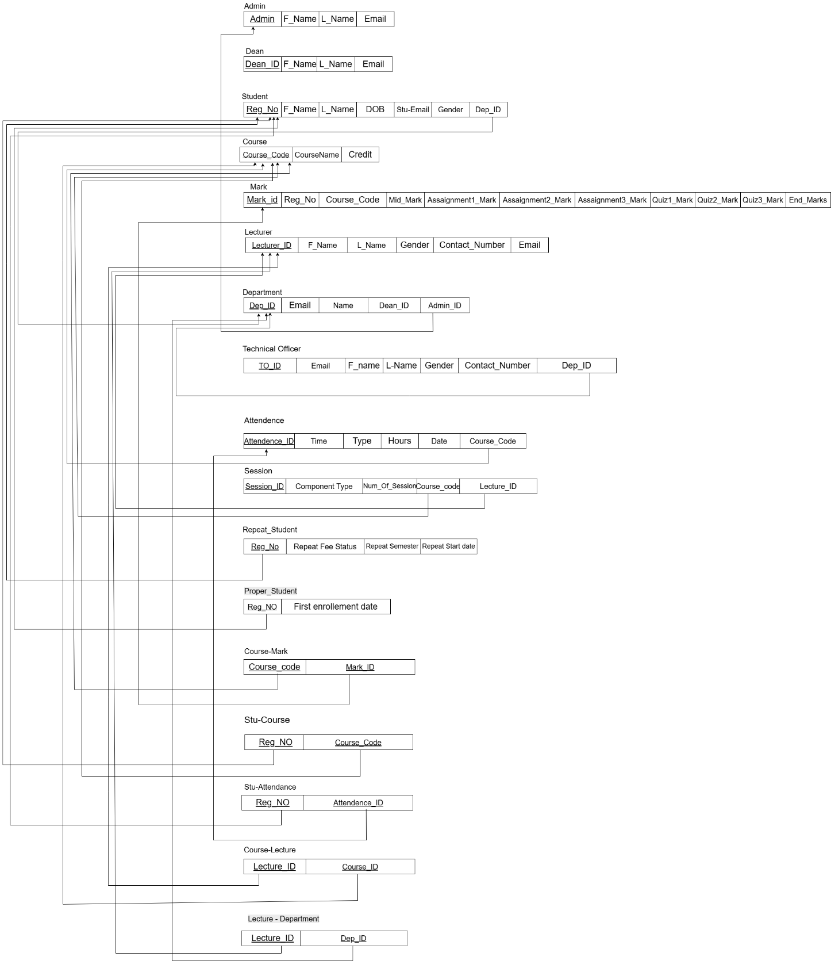

Proposed Relational mapping Diagram.

Table structure of your solution

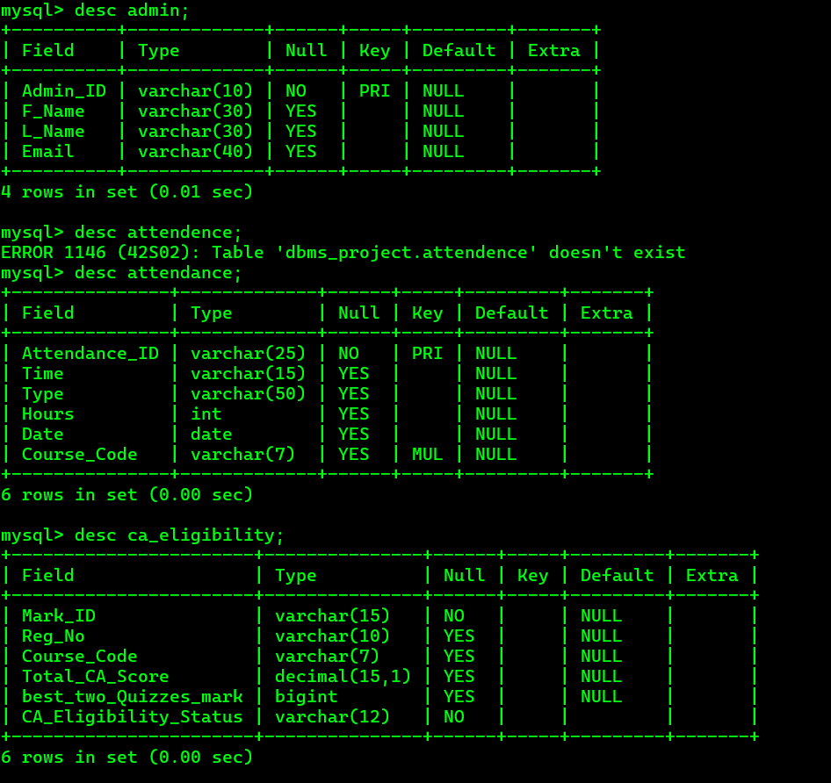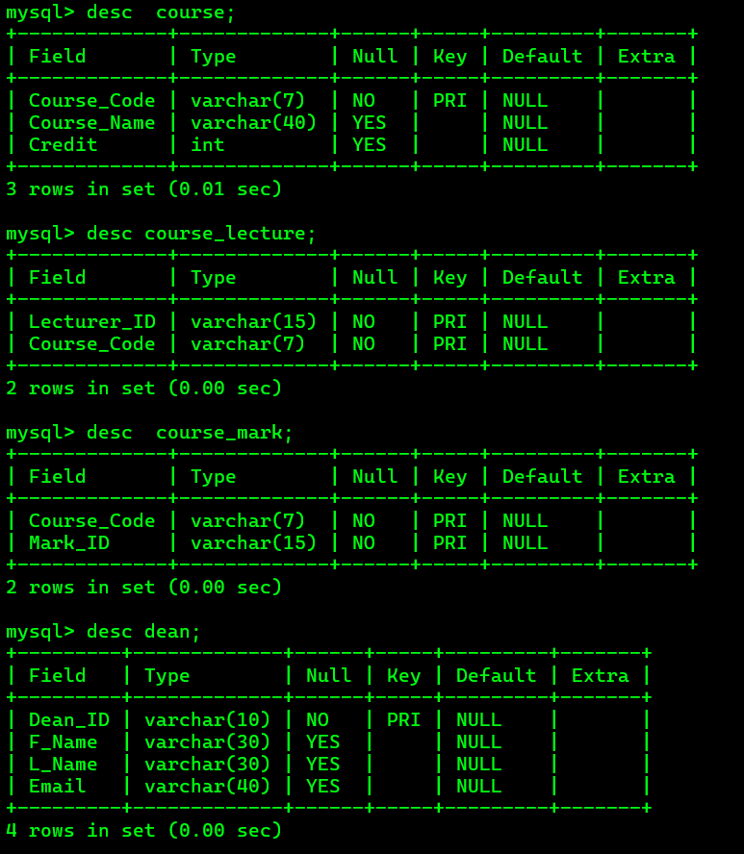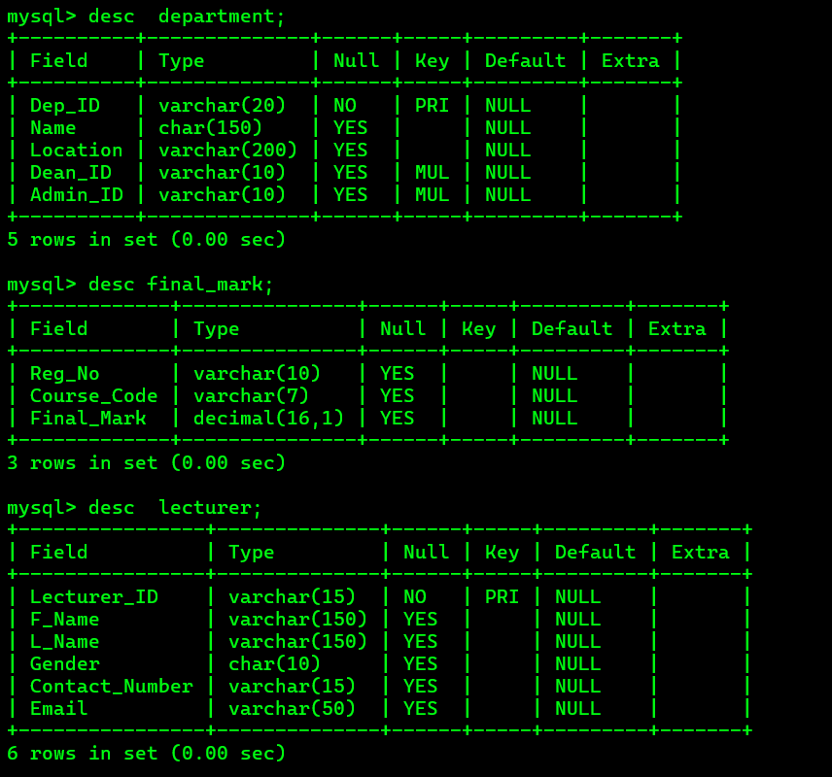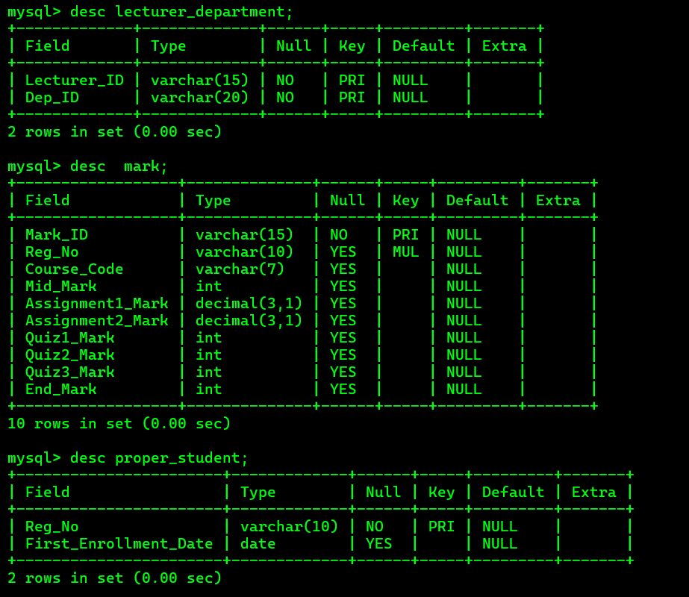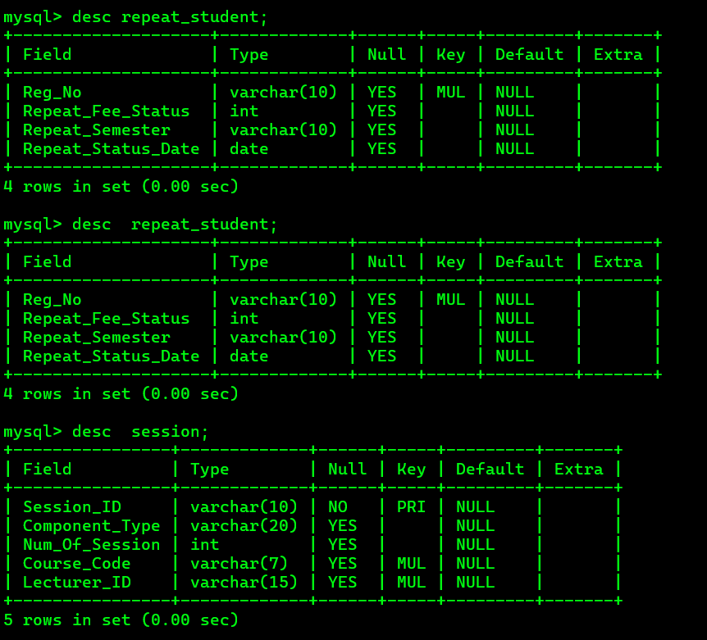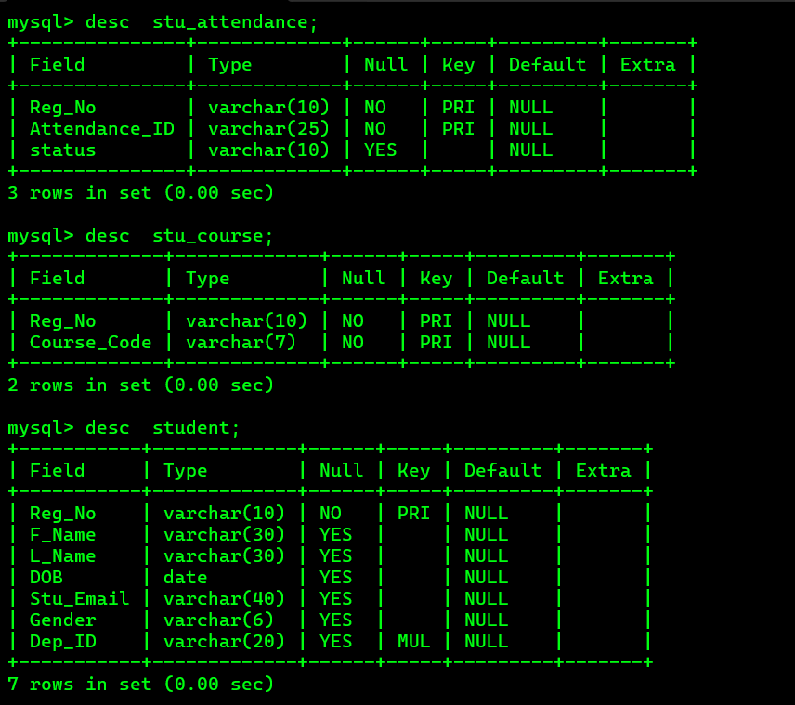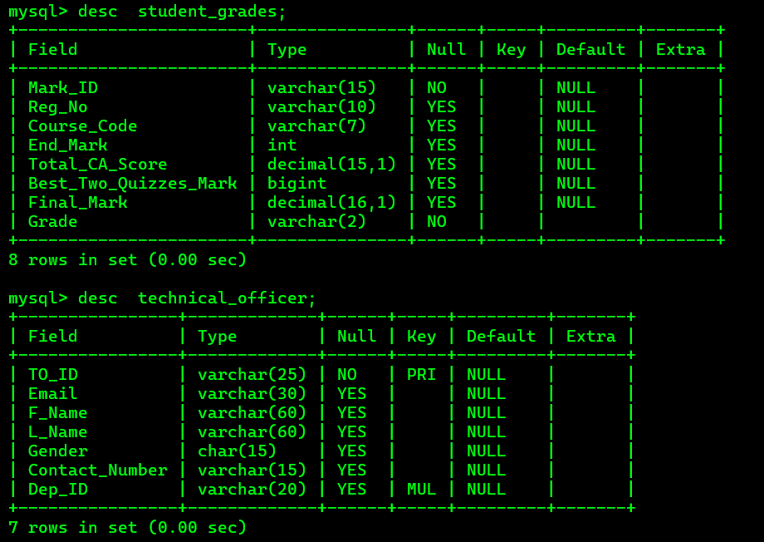

Architecture of your solution
User Interface
⬇
Application / Business Logic Layer
⬇
MySQL Database

- The user (Student / Lecturer / Technical Officer / Admin / Dean) logs into the system.
- The Application Layer handles data validation, processing, and communication with the MySQL backend.
- The MySQL Database Layer stores all students, lecturers, marks, and attendance data and results.

Tools and technologies that you have used.
- Draw.io:
Used to draw ER diagram,relational schema and table structure.
- MySQL SERVER,Vs code, Notepad:
Used to create database and maintain.
- GitHub and GitHub Desktop: Version Control

Security measures that have taken to protect your DB
- Admin - With All privileges with Grant Option for all the tables in the database
- Dean - With All privileges without Grant for all the tables in the database
- Lecturer – All privileges without Grant and user creation for all the tables in the database
- Technical Officer - Read, write, and update permissions for attendance related tables/views
- Student - Read permission for final attendance and final marks/Grades tables/views

Brief description about DB Accounts/Users and the reasons for creating such

Accounts/Users.
- Admin
Admin can access full system. Maintain database.
- Dean
Admin can access full system. Maintain database.
- Lecturer
Access course table and exam marks table and maintain.
Can Update table.
- Technical Officer maintain Read, write and update permissions for attendance related tables/views. • Student
Access course tables and can only view marks.

Code snippets to support your work.

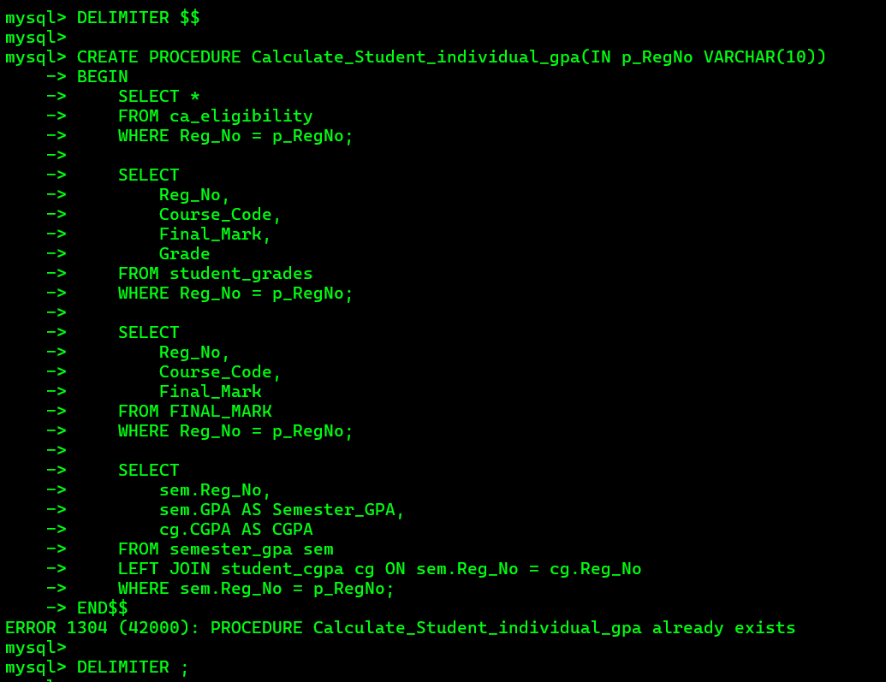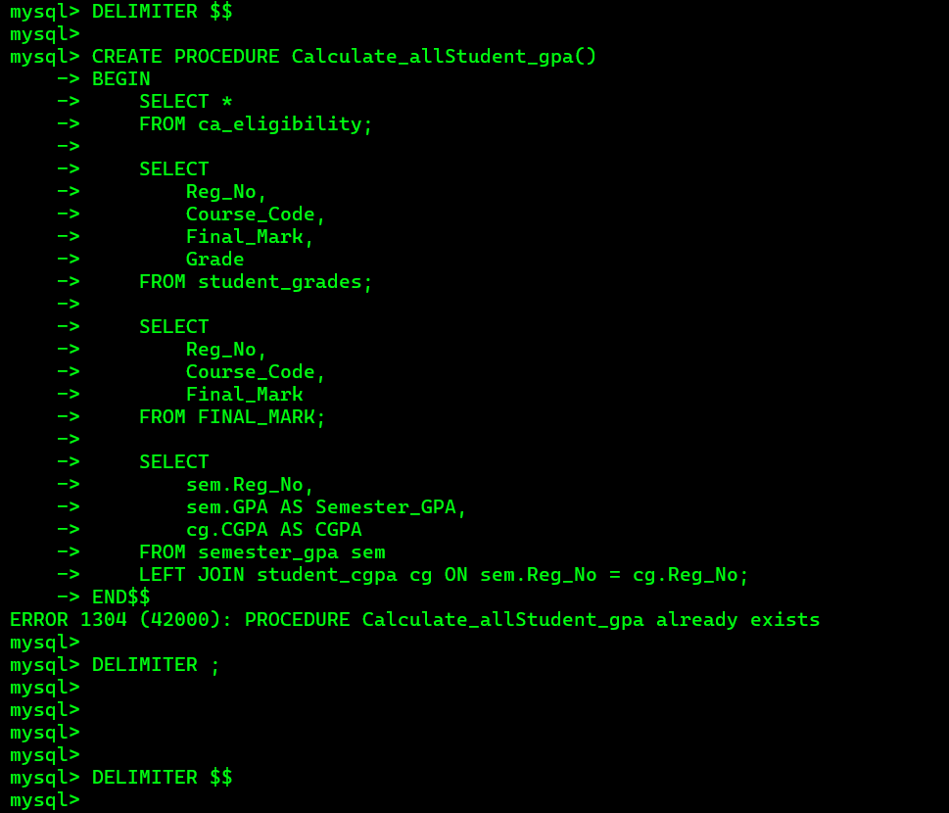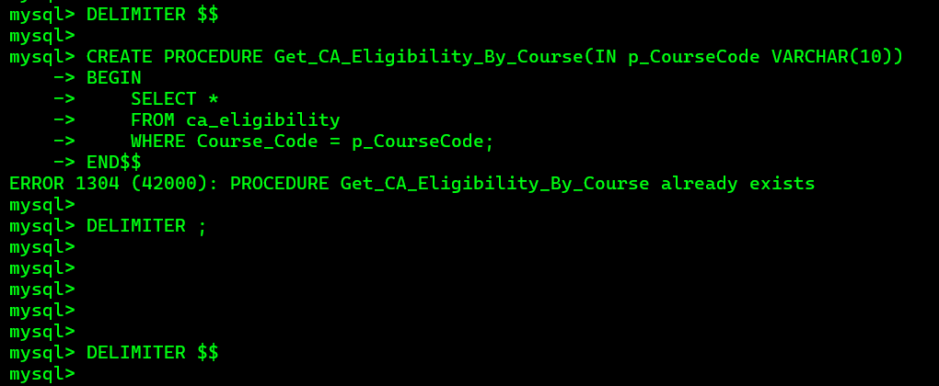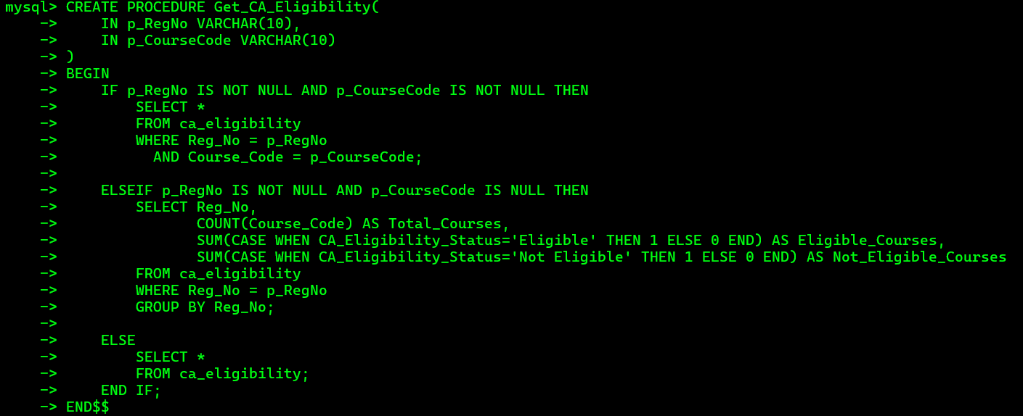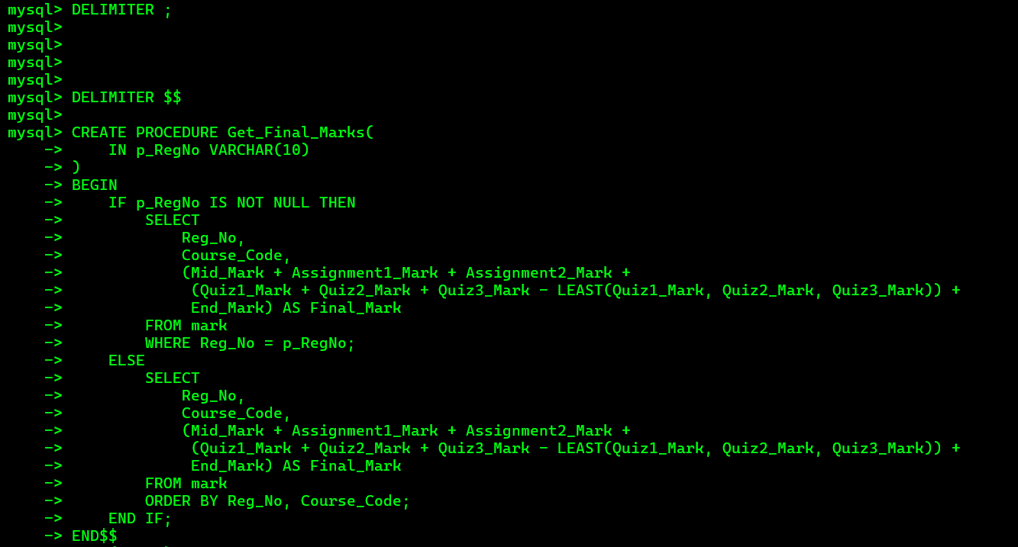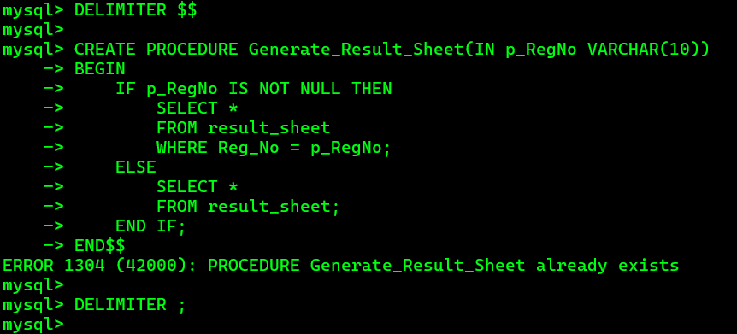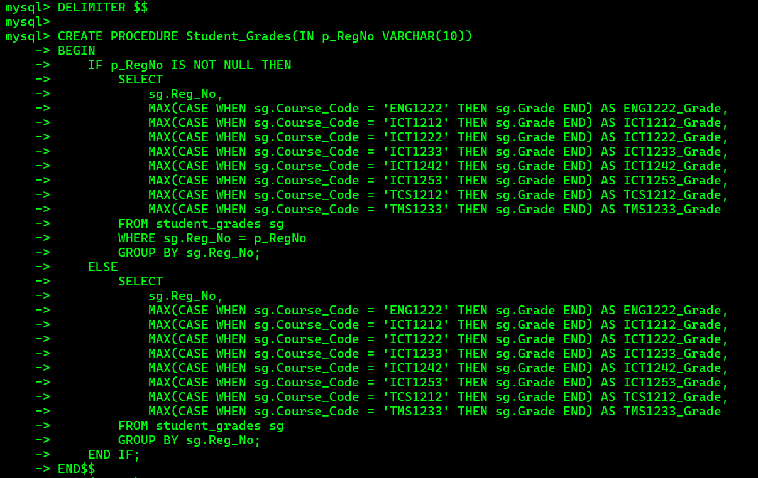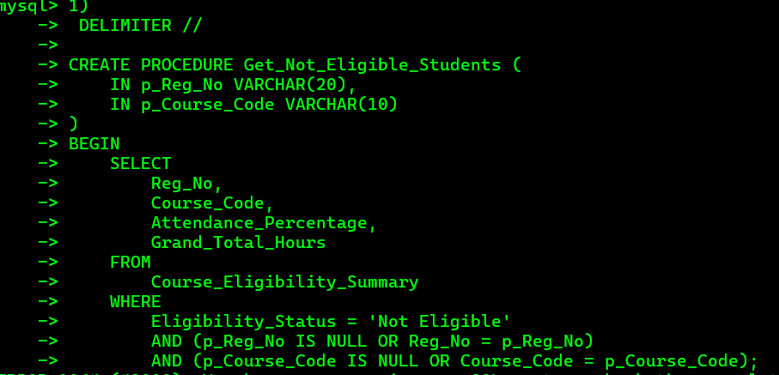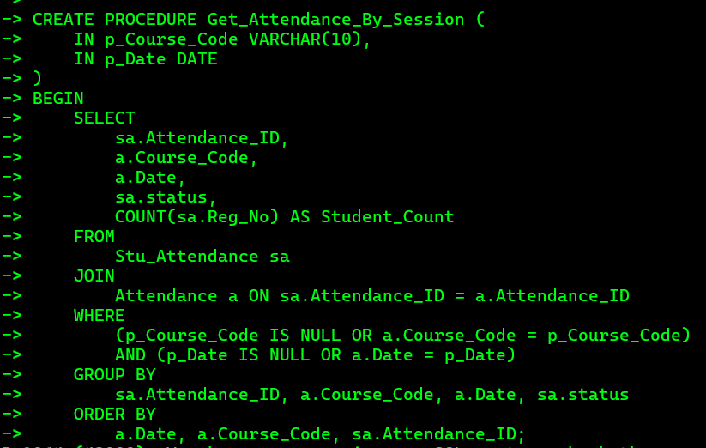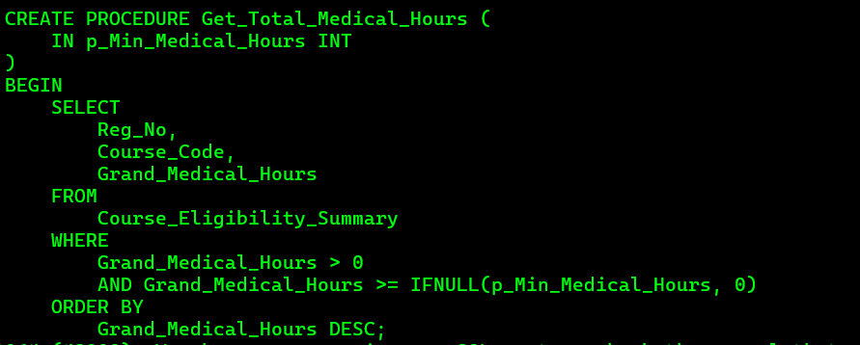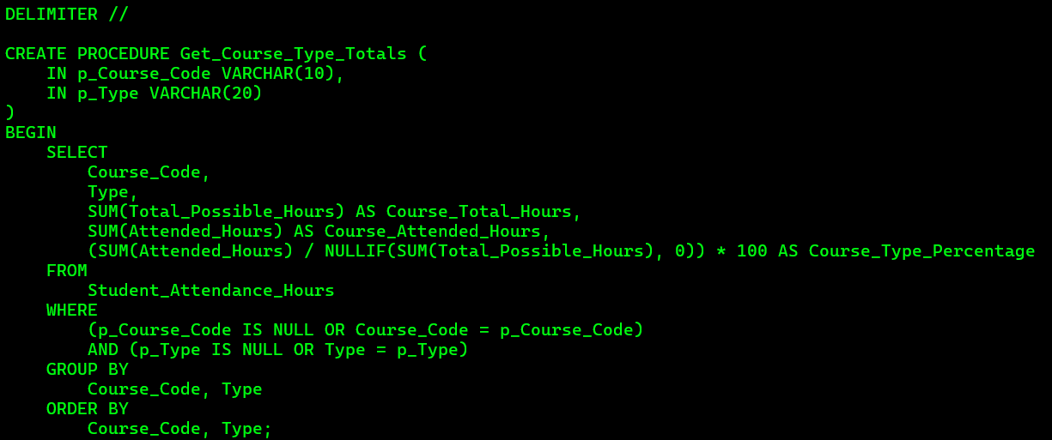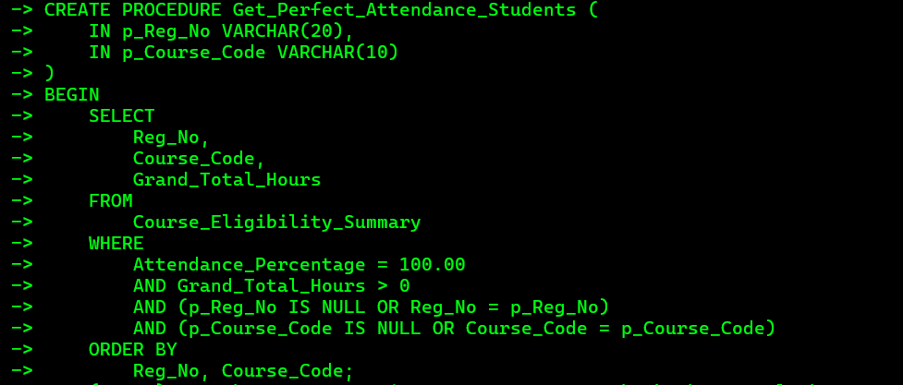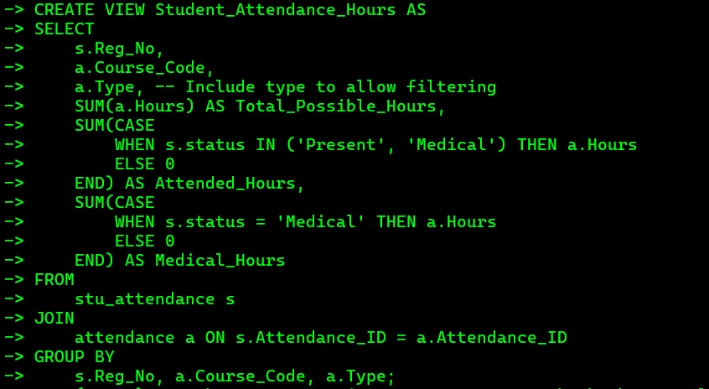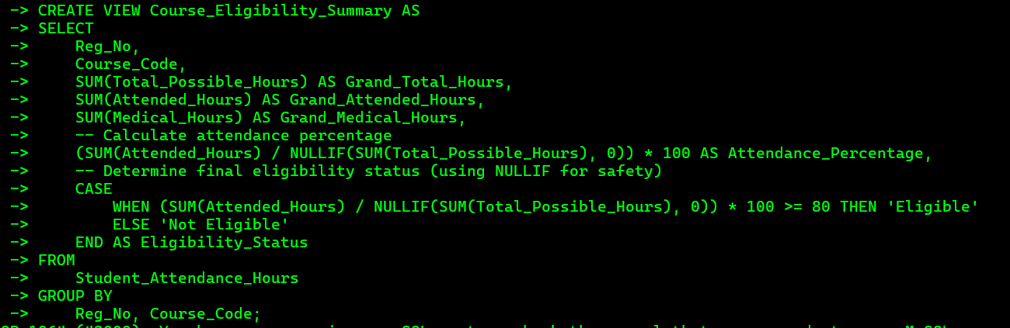

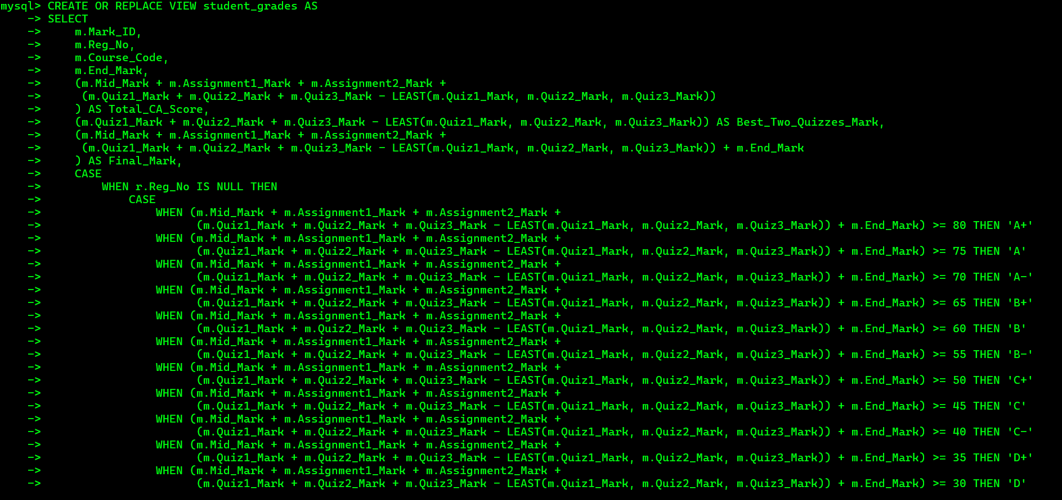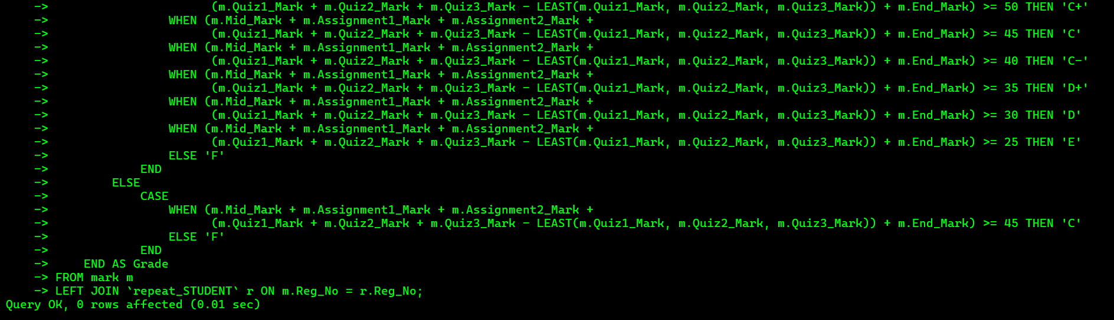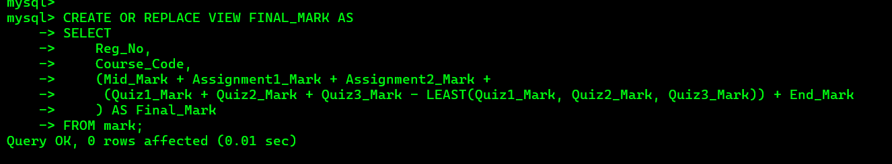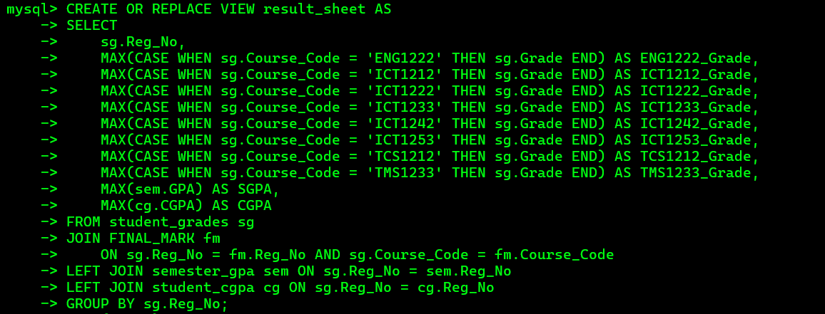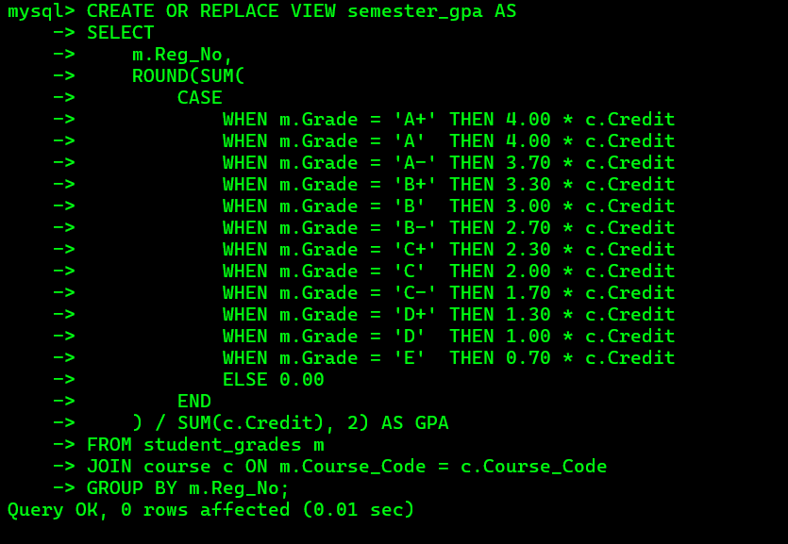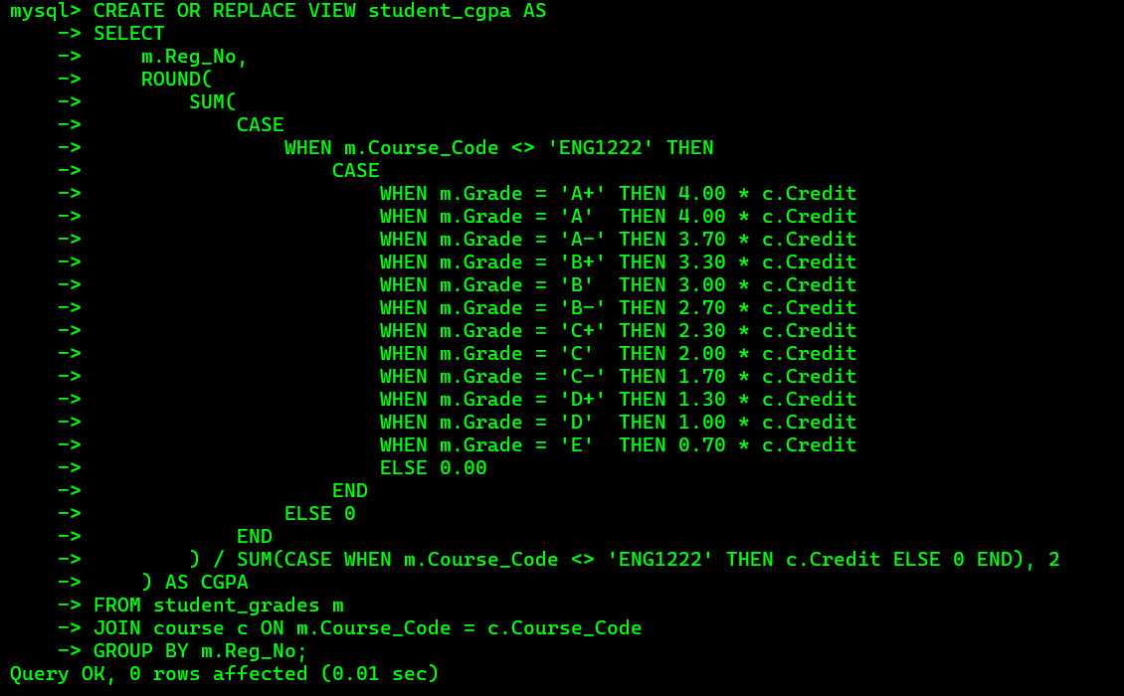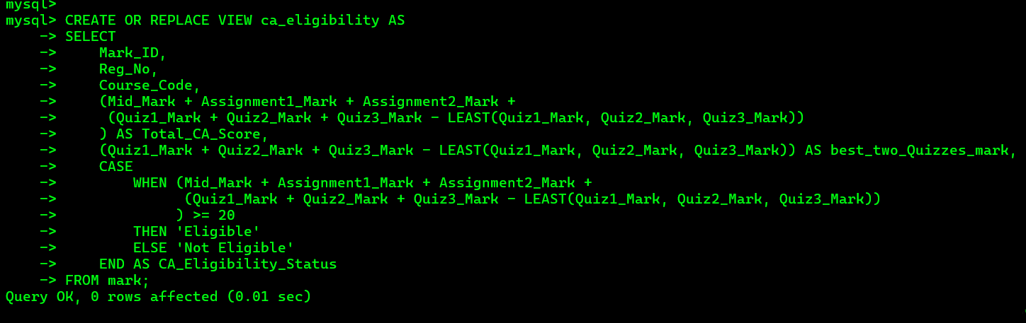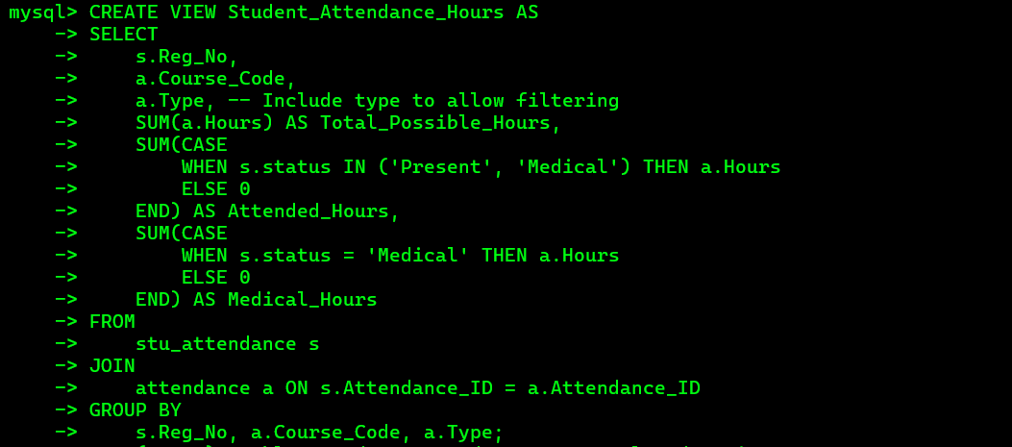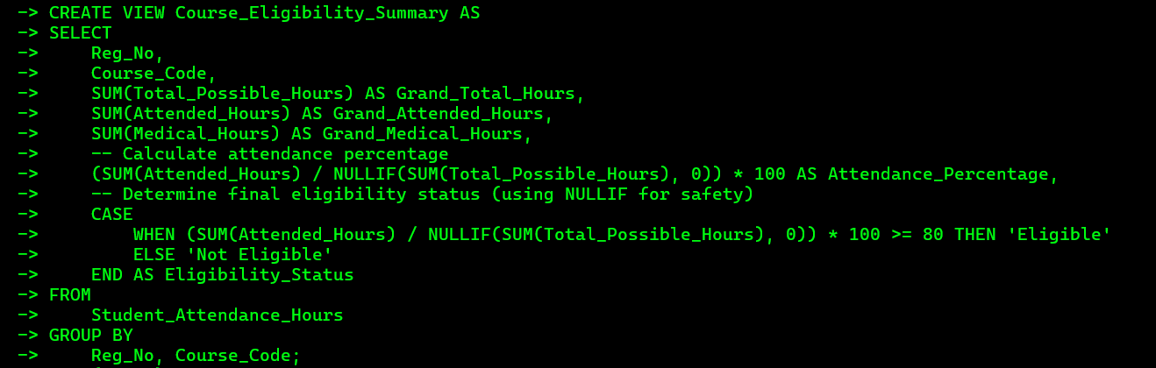

Problems Faced During Development
- Complex Table Structures: Creating tables like attendance and exam marks was challenging, especially in determining appropriate foreign keys.
- Data Maintenance: Managing and updating data in tables such as attendance and marks was cumbersome and prone to errors.
- Diagram Adjustments: Frequent modifications were needed for the ER diagram and relational map to align with system requirements.
- Data Type Errors: Errors related to incompatible data types arose when inserting data into tables.

Solutions to Overcome Identified Problems
- Modular Data Sets: Divided attendance data into separate files by weekdays to streamline entry and reduce complexity.
- Automated Data Typing: Implemented repetitive typing checks for attendance data to ensure consistency and minimize input errors.
- Dynamic Diagram Updates: Updated the ER diagram and relational map as needed to reflect new requirements, ensuring alignment with database structure.
- Data Validation Checks: Introduced pre-insertion data validation to catch and resolve data type mismatches early.

If I were to host the database backend, We would choose a cloud provider like
- Amazon Web Services (AWS)
- Microsoft Azure
- Google Cloud Platform (GCP) for the following reasons:

If you are going to host your backend in a cloud environment what are the

things/changes that you have to do in your backend.
- We want to buy a database server and creating data base into the online server.
- Change some data types.
- We have a lots of data in our database.

Individual contribution to the backend development.



TG/2023/1715 A.P.G.H.Pramoda

This report presents my individual contribution to the development of the Student Management System, a comprehensive SQL-based project designed to manage academic data efficiently within a university environment. My primary role involved designing and implementing advanced database components, including views, stored procedures, and triggers, to automate academic processes such as assessment calculations, medical handling, and eligibility evaluation. These contributions were focused on ensuring data consistency, transparency in grading, and accuracy in reporting.

Development of Database Views

Academic Data Streamlining: Attendance and Eligibility Views
A major part of my contribution was the creation of multiple database views to streamline academic data retrieval and calculation processes, specifically focusing on attendance tracking and assessment eligibility.
View Name | Core Purpose | Key Business Logic & Calculations
Student_Attendance_Hours | Calculates and summarizes total possible hours, attended hours, and medical hours for every student/course/type combination. | Precise Hour Aggregation: Uses conditional aggregation (CASE statements) to accurately sum hours, ensuring that 'Present' and 'Medical' statuses are counted toward Attended_Hours. Separately isolates Medical_Hours for detailed reporting. Aggregates data by student, course, and class type (a.Type).
Course_Eligibility_Summary | Determines a student's final Attendance Percentage and Eligibility Status for a course. | Eligibility Rule Enforcement: Calculates the Attendance_Percentage using the formula: (\mathbf{Grand\_Attended\_Hours} / \mathbfGrand\_Total\_Hours) \times 100%. Implements the core academic rule: sets Eligibility_Status to 'Eligible' if the percentage is 80% ensuring reliable compliance checking. Uses NULLIF to prevent division-by-zero errors.

Database Table Design

Table | Purpose | Primary Key (PK) | Key Relationships (Foreign Keys)
Department | Defines the main organizational units (e.g., School of ICT). | Dep_ID | Linked to Lecturer and Technical Officer (staff affiliation).
Lecturer | Stores records for the academic teaching staff. | Lecturer_ID | Linked to Department (affiliation) and Session (scheduling/assignment).
Technical Officer | Stores records for administrative or technical support staff. | TO_ID | Linked to Department (affiliation).
Session | Defines the planned template for a course event (e.g., "Lecture Type A" occurs 10 times). | Session_ID | Linked to Course (what is taught) and Lecturer (who is assigned).
Attendance | Records the actual occurrence of an academic event (date, time, hours). | Attendance_ID | Linked to Course (what session it was for) and serves as the parent for attendance marks.
Stu_Attendance | The junction table that records a student's mark for a session. | Composite PK: Reg_No + Attendance_ID | Linked to Student (who was marked) and Attendance (the mark status for that specific session).

Creation of Stored Procedures
Stored Procedure Summary: Targeted Attendance and Eligibility Reporting
Procedure Name | Core Purpose | Key Value Delivered
Get_Not_Eligible_Students | Identifies students who fail to meet the minimum attendance requirement for any or a specified course. | Intervention Reporting: Provides a quick, actionable list of students needing academic warning or counseling based on their Eligibility_Status being 'Not Eligible'.
Get_Attendance_By_Session | Audits the session-by-session attendance breakdown, showing the count of students for each status (Present, Absent, Medical) per class meeting. | Data Verification & Auditing: Allows administrators to verify attendance records for a specific date and course, ensuring the integrity of the raw data by providing a head-count summary per status.
Get_Total_Medical_Hours | Tracks medical-related absences, listing students who have accumulated more than a specified minimum number of medical hours. | Welfare & Policy Review: Helps identify students with high levels of documented medical leave, which may trigger institutional policy checks or require welfare intervention.
Get_Course_Type_Totals | Calculates the aggregate attendance percentage for specific class types (e.g., 'Lecture' or 'Practical') within a course or across all courses. | Curriculum Analysis: Offers a high-level view of attendance trends for different instruction formats, aiding quality assessment of delivery methods.
Get_Perfect_Attendance_Students | Recognizes students who achieved attendance in a course. | Recognition & Promotion: Generates lists for awards or commendations, promoting excellent student engagement and punctuality.

4. Summary of Contribution
My overall contribution demonstrates the development of a robust, rules-based Academic Data Management System centered on ensuring compliance, calculating performance, and automating reporting for critical institutional processes.
My work spans three key architectural layers: Data Aggregation, Rule Enforcement, and Reporting.
1. Data Aggregation and Calculation (Views)
I have established a reliable, centralized source of truth for academic metrics by creating six key views. This eliminated manual, error-prone calculations by embedding the business logic directly into the database:
- Mark Calculation: Views like CAView and EndMarkView apply complex, weighted scoring rules (e.g., mark for quizzes, best-of-two selection) to combine raw scores into final marks.
- Attendance and Eligibility: Student\_Attendance\_Hours and Course\_Eligibility\_Summary accurately track and aggregate attendance, applying the non-negotiable and minimum attendance rule to produce the final Eligibility_Status.
- Final Summary: The StudentGrades view acts as the ultimate academic record, integrating marks, attendance, GPA, and handling special student statuses (e.g., Medical, Repeat) under logical grading rules.

2. Automated Reporting and Auditing (Stored Procedures)
I have developed five flexible stored procedures that transform the calculated data from your views into actionable reports, significantly enhancing administrative efficiency:
- Compliance Monitoring: Procedures like Get_Not_Eligible_Students immediately identify failure to meet the attendance threshold, serving as a critical intervention tool.
- Data Integrity: Get_Attendance_By_Session provides a crucial auditing mechanism, allowing staff to verify raw attendance counts (Present, Absent, Medical) for any specific class meeting.
- Targeted Analysis: Procedures like Get_Course_Type_Totals and Get_Total_Medical_Hours enable detailed analysis of attendance trends by instruction type (Lecture, Practical) and track student welfare issues related to medical leave.

Overall Value and Impact
My contribution delivered a streamlined system that achieved consistency, efficiency, and compliance:
- Reduced Manual Workload: Automated complex calculations for marks and eligibility, saving academic staff significant time.
- Enhanced Fairness: Standardized the application of all grading and eligibility policies across the institution.
- Improved Decision-Making: Provided instant, accurate reports necessary for student advising, academic warnings, policy enforcement, and final grade board approvals.
In essence, I have built the analytical backbone of the academic reporting system, moving the institution from manual data processing to rule-based, instantaneous reporting.

5. Detailed Contribution Analysis
Detailed Contribution Analysis: Advanced SQL Logic for Attendance & Eligibility
My contributions went beyond core data modeling by implementing advanced SQL logic to handle complex scenarios in the academic environment, ensuring robust data integrity and policy adherence within the Attendance and Eligibility module.
- Medical and Exceptional Case Handling:
  - Through the design of the Student_Attendance_Hours view, the system is capable of accurately tracking hours related to Medical statuses.
  - The conditional logic (CASE WHEN s.status IN ('Present', 'Medical') THEN a.Hours) ensures that medically approved hours are automatically counted toward the student's attended total (Attended_Hours), reducing manual intervention and ensuring fairness in the final eligibility calculation.
  - The Get_Total_Medical_Hours stored procedure further supports this by specifically flagging students with high volumes of medical absences for necessary follow-up.
- Eligibility Evaluation:
  - The Course_Eligibility_Summary view serves as the core policy enforcement engine. It was designed to combine aggregated attendance hours into a single Attendance_Percentage and applies the critical minimum attendance threshold to determine the final Eligibility_Status.
  - This logic ensures all necessary attendance criteria are met before a student is declared 'Eligible' for final assessments.
- Robust Data Reporting and Integrity:
  - To maintain consistency, the Course_Eligibility_Summary uses the NULLIF function to prevent crippling division-by-zero errors in the attendance percentage calculation, ensuring the report remains robust even with incomplete session data.
  - The stored procedures, such as Get_Not_Eligible_Students and Get_Attendance_By_Session, were designed with flexible IS NULL parameter checks, enabling staff to execute broad reports (all courses) or highly specific audits (one student in one course) with a single, highly efficient procedure call. This significantly enhances Reporting Efficiency.
.

6. Impact of my contributions
The primary impact of your contribution was establishing a fair, automated, and error-free system for managing student attendance and assessment eligibility.
Your work achieved three key benefits for the institution:
- Guaranteed Compliance: You have built the attendance rule directly into the database, ensuring the policy is enforced automatically and consistently for every student.
- Zero Manual Errors: By automating the tracking of hours (including medical absences) and calculating eligibility, you eliminated the need for staff to manually crunch numbers, drastically reducing the risk of errors.
- Instant Reporting: Your procedures give staff immediate access to critical reports (like who's "Not Eligible" or who has high "Medical Hours"), allowing for quick decision-making and student intervention.
In short, you transformed a manual, error-prone process into a reliable, rule-based, and efficient automated system.

My Github link- https://github.com/NIpYo7/DBMS_Project.git

TG/2023/1771 R.W.V.N MADUSANKA


For the work in the Learning Management System (LMS) database design and development, I made significant contributions that strengthened the system's foundational structure and operational efficiency. My efforts included creating several key tables, drawing the EER diagram, developing stored procedures and views, inserting data into all tables, finalizing individual queries for the final results, and fixing errors in the code. These contributions ensured a robust, scalable, and automated database solution tailored to academic needs.
Database Design and Implementation
I designed and implemented critical tables that form the backbone of the LMS. The Dean table captures dean details such as Dean_ID (primary key), names, contact information, and department affiliations, enabling centralized faculty management. The Student table stores student records including Reg_No (primary key), names, batch details, contact info, and enrollment status, with constraints to maintain uniqueness and integrity with courses. The Department table organizes departments by Dep_ID (primary key), names, locations, and links to deans and admins, supporting structured academic hierarchies. The Admin table manages administrator data with Admin_ID (primary key), credentials, permissions, and department associations, ensuring secure system oversight. These tables, linked via foreign keys, enforce data consistency and support role-based access across the LMS.
Enhanced Entity-Relationship (EER) Diagram
I also drew the Enhanced Entity-Relationship (EER) diagram, which mapped out entities like Student, Course, Mark, and Attendance, their attributes, relationships (e.g., one-to-many between Lecturer and Course), and cardinalities, including special cases like repeat students. This diagram guided the relational schema design, ensured normalization, and helped implement constraints to optimize performance and scalability.
Stored Procedures
• Get_CA_Eligibility(IN p_RegNo VARCHAR(10), IN p_CourseCode VARCHAR(10)): Determines CA eligibility based on attendance (80% minimum) and CA marks (20% minimum). Purpose: Facilitates quick eligibility checks for exams, reducing manual effort.
• Get_Final_Marks(IN p_RegNo VARCHAR(10)): Calculates final marks by summing mid-mark (20%), assignments (5% each), best two quizzes (10%), and end-mark (50-60%). Purpose: Ensures consistent final score computation for grading.
• Generate_Result_Sheet(IN p_RegNo VARCHAR(10)): Produces a result sheet with grades, SGPA, and CGPA. Purpose: Generates comprehensive academic reports.
• Student_Grades(IN p_RegNo VARCHAR(10)): Pivots grades for courses like ENG1222 and ICT1212. Purpose: Provides an overview of student performance across courses.
Views
• student_grades: Computes Total_CA_Score, Best_Two_Quizzes_Mark, Final_Mark, and assigns grades (A+ to F), with adjusted rules for repeat students (C if >=45, else F).
• FINAL_MARK: Aggregates all mark components into a Final_Mark. Purpose: Offers a quick total score reference.
• result_sheet: Pivots grades, includes SGPA and CGPA. Purpose: Creates formatted result summaries.
Data Insertion and Testing
I inserted data into all tables, populating them with realistic records for admins, deans, departments, students (50+ entries), courses, marks (120+ entries), attendance (8 weeks across courses), and eligibility, ensuring comprehensive testing of relationships and constraints.
Query Integration and Debugging
I finalized all individual queries by integrating them into a cohesive set for the final results, ensuring alignment with project goals. Additionally, I fixed code errors, such as syntax issues in CASE statements, NULL handling with LEAST/COALESCE, constraint violations, and logic errors in grade assignments for edge cases like medical exemptions, enhancing system reliability.
Impact of My Contributions
My contributions established a solid database structure, enabling efficient user management and academic automation. The tables and EER diagram ensured scalability, while procedures and views streamlined grading and reporting, reducing errors. Data insertion and error fixes prepared the system for practical use, improving transparency and efficiency for students, lecturers, and administrators. Furthermore, the automated generation of academic reports through procedures like Generate_Result_Sheet and views like result_sheet has significantly enhanced the ability to produce timely and accurate transcripts, progress reports, and performance summaries, which are crucial for academic planning and student counseling. This comprehensive approach not only supports current academic needs but also provides a flexible foundation for future enhancements, such as integrating additional modules for online learning or advanced analytics, thereby fostering a more dynamic educational environment.

G. G. N. S. Bandara (TG/2023/1763)
University of Ruhuna – Department of ICT


1. Introduction
The “University Database Management System” is a database project developed to manage student, lecturer, and course-related data efficiently within a university environment. The main purpose of this system is to make university academic information, such as grades, GPA, attendance, and eligibility, easily available and well organized.
This project was developed using MySQL as the main database management system. The database includes multiple tables, views, and stored procedures that help automate the calculation of GPA, CGPA, and Continuous Assessment (CA) eligibility for students.
The project was created as part of the Database Management Systems module to demonstrate practical skills in database design, normalization, and SQL programming.
2. Objectives
The main objectives of this project are:
1. To design and implement a database system for managing university academic information.
2. To create tables and relationships among students, lecturers, courses, and marks.
3. To develop SQL views and stored procedures to automate the calculation of GPA, CGPA, and CA eligibility.
4. To provide an easy and accurate method for the university to view student performance.
5. To apply the concepts of database design, normalization, and SQL in a real-world project.
3. System Overview
This University Database Management System mainly focuses on managing the following data:
- Student registration and course enrollment.
- Lecturers and their assigned departments or subjects.
- Marks and grades for each student in each course.
- Eligibility checking for Continuous Assessments (CA).
- GPA and CGPA calculation for each student.
The database structure is designed to maintain data integrity and avoid redundancy by using relationships between tables.
4. Database Design
The system includes several important tables:
- Student – stores student details with registration numbers.
- Course – contains course information such as course code, course name, and credit value.
- Mark – stores marks for each student including mid marks, assignments, and quizzes.
- Student_Grades – includes the final marks and grades for each student.
- Lecturer, Department, Course_Lecture, and Lecturer_Department – manage lecturer and department details.
- Stu_Course – maintains which student is enrolled in which course.
- Repeat_Student and Proper_Student – manage repeat course details and initial enrollments.
All tables are connected using primary keys and foreign keys to ensure relational integrity.
5. Views and Procedures (Your Contribution)
In this project, my main contribution focused on creating SQL Views and Stored Procedures that help to automate data analysis.
5.1 View: semester_gpa
This view calculates the Semester GPA for each student based on their grades and course credits. It uses a weighted average formula to convert letter grades into grade points.
CREATE OR REPLACE VIEW semester_gpa AS
SELECT
m.Reg_No,
ROUND(SUM(
CASE
WHEN m.Grade = 'A+' THEN 4.00 * c.Credit
WHEN m.Grade = 'A' THEN 4.00 * c.Credit
WHEN m.Grade = 'A-' THEN 3.70 * c.Credit
WHEN m.Grade = 'B+' THEN 3.30 * c.Credit
WHEN m.Grade = 'B' THEN 3.00 * c.Credit
WHEN m.Grade = 'B-' THEN 2.70 * c.Credit
WHEN m.Grade = 'C+' THEN 2.30 * c.Credit
WHEN m.Grade = 'C' THEN 2.00 * c.Credit
WHEN m.Grade = 'C-' THEN 1.70 * c.Credit
WHEN m.Grade = 'D+' THEN 1.30 * c.Credit
WHEN m.Grade = 'D' THEN 1.00 * c.Credit
WHEN m.Grade = 'E' THEN 0.70 * c.Credit
ELSE 0.00
END
) / SUM(c.Credit), 2) AS GPA
FROM student_grades m
JOIN course c ON m.Course_Code = c.Course_Code
GROUP BY m.Reg_No;
5.2 View: student_cgpa
This view calculates the Cumulative GPA (CGPA) for each student. It ignores some specific courses (like “ENG1222”) during the calculation.
5.3 View: ca_eligibility
This view calculates the total CA marks (mid, assignment, and quiz marks). If the total is 20 or above, the student becomes Eligible for the final exam.
CREATE OR REPLACE VIEW ca_eligibility AS
SELECT
Mark_ID,
Reg_No,
Course_Code,
(Mid_Mark + Assignment1_Mark + Assignment2_Mark +
(Quiz1_Mark + Quiz2_Mark + Quiz3_Mark - LEAST(Quiz1_Mark, Quiz2_Mark, Quiz3_Mark))
) AS Total_CA_Score,
CASE
WHEN (Mid_Mark + Assignment1_Mark + Assignment2_Mark +
(Quiz1_Mark + Quiz2_Mark + Quiz3_Mark - LEAST(Quiz1_Mark, Quiz2_Mark, Quiz3_Mark))
) >= 20
THEN 'Eligible'
ELSE 'Not Eligible'
END AS CA_Eligibility_Status
FROM mark;
5.4 Stored Procedure: Calculate_Student_individual_gpa
This procedure retrieves all marks, CA eligibility, GPA, and CGPA for a single student by entering the registration number.
5.5 Stored Procedure: Calculate_allStudent_gpa
This procedure retrieves GPA and CGPA details for all students in the database.
5.6 Stored Procedure: Get_CA_Eligibility_By_Course
This procedure displays the CA eligibility of students for a specific course.
6. Results and Discussion
After implementing the database and executing the SQL views and procedures, the system successfully performs:
- Automatic GPA and CGPA calculation based on student grades and course credits.
- Eligibility checking for students according to their CA marks.
- Data summarization through SQL views.
- Individual and overall reports for students and courses using stored procedures.
The system improves efficiency, accuracy, and data consistency within the university’s academic record management.
7. Conclusion
The University Database Management System is an efficient solution for managing academic data in a university. By implementing this project, I learned how to:
- Design normalized database structures.
- Use SQL joins, views, and stored procedures effectively.
- Automate academic data management processes.
- Improve understanding of real-world database applications.
This project demonstrates the importance of database management in modern education systems and provides a strong foundation for future database-related projects.
8. References
1.MySQL Documentation – https://dev.mysql.com/doc/
2.Course Materials – University of Ruhuna, Department of ICT
3.SQL Tutorial – w3schools.com

References:
- w3cschool.com
- Lecture Materials

